Programming Concepts  
Week 1 **Pass** Submission Tasks Template

Student ID: ______103055993_______________

Student Name: ________Mario Stavreski______________________

## Pass Task 6 web page

Paste the screen capture of the html web page as shown by the browser here.

## Pass Task 6 html code

Paste the html code of the same page here.

## Pass Task 12 First test

Paste the screen capture of the web page as shown by the browser here (specify in comments or make additional screenshots of data you entered for testing).

## Pass Task 12 Second test

Paste the screen capture of the web page as shown by the browser here (specify in comments or make additional screenshots of data you entered for testing).

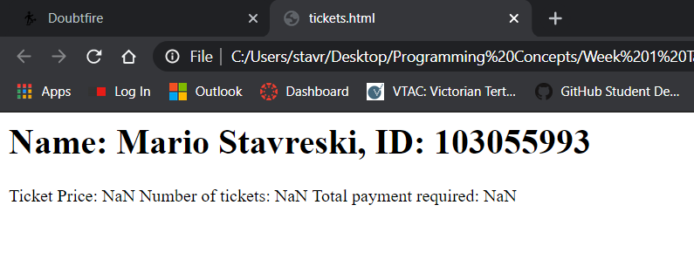

## Pass Task 12 html code

Paste the html code of the same page here.

## Pass Task 12 JavaScript code

Paste the JavaScript code here.

